**Lab - Creating a Virtual install of Kali using VMWare**

**Caveat**

Be sure to read the lab in its entirety before starting this or any lab in the course! Skipping a step in any part of the lab will cause the lab to fail. Trying to blow through this lab will result in epic failure! Slow and steady wins the race.

**Requirements:**

1. Kali Linux Preinstalled Image: (**~3.6 GB**)
2. VMWare: (**~107 MB**)
3. A CPU that supports Virtualization.
4. 8GB of RAM preferred. (4 GB of RAM will Suffice but is not optimal)
5. At least 60 GB of free hard drive space. (An external hard drive or thumb drive can also be used as storage)

**Using Other Hypervisors**

For all the gunslingers in the course, if you are using some other hypervisor to create your virtual lab environment, you are good to go. No need to check with the instructor.

This lab will walk through the creation and installation of a Kali Linux virtual machine inside VMWare using a prebuilt Kali image. Kali will function as our attack machine for all subsequent labs.

**How much time to allocate for this lab**

The whole process may take a few hours to complete depending on the specifics of your own situation, i.e., computer, internet connection speed, and so on.

Any software referenced in this lab is free and open source, just like Kali.

As the lab begins, students will be taken through the download process for any downloads. All software has been verified to be malware and crapware free.

**Begin the lab!**

**Install Kali Linux in VMWare Using a Pre-Built Image**

**1. Download and install VMWare**

There is no version of VMware Player for OS X (MAC, Apple). Instead, VMware sells a Mac version of their product called [VMware Fusion](http://www.vmware.com/products/fusion). You may use it as a 30-day free trial version. If you don't want to purchase VMware Fusion, you can:

* Purchase and install Parallels for MAC to create a virtual install of Kali Linux
* Use VirtualBox. VirtualBox is free and can use the same OVA image file downloaded for this lab.

The first step is to download and install the **VMWare** software package onto the host machine chosen for your lab setup. Make sure your hardware is 64bit as this is the only version available for VMWare.

Once downloaded, **VMWare** installs like any other software program. Find your download and begin installing. **VMWare** is malware, adware, spyware, and crapware free.

[Download here!](http://www.vmware.com/products/player/playerpro-evaluation.html)

**2. Download and install Free Download Manager**

Download managers allow you schedule, start, stop, and resume a download without loss of any downloaded progress. When downloading gigabytes of data and needing to start over is very frustrating. Download managers can also reduce up your download time.

For this lab, I used a download manager called **Free Download Manager**.

Install Free Download Manager to your host machine. Find your download and begin the installing. The **Free Download Manager** is malware and crapware free.

[Download here!](http://www.freedownloadmanager.org/)

**3. Download the Right Kali image**

**Important note!**

**This lab uses the prebuilt image built for VMWare. The VMWare image is built and packaged using the ‘Open Virtualization Format’ (OVA). An OVA is an OVF file packaged together with all its supporting files (disk images, etc.).**

**In September 2007 VMware, Dell, HP, IBM, Microsoft and XenSource submitted to the Distributed Management Task Force (DMTF) a proposal for OVF, then named "Open Virtual Machine Format."**

**Do not download the Kali image for VirtualBox! Download the image built for VMWare! The VMWare image is much smaller than the one built for VirtualBox. It took me roughly 2.5 hours to update as opposed to the VirtualBox image which much less time.**

Using a pre-installed file saves us a lot of time as we won’t have to step through the installation process.

For install method, we need to use the Free Download Manager to ensure our download is uninterrupted and timely.

Since the Kali images are updated over time, the file for the download will differ than what is in the lab, but it remains the same file, just with updates. Visit the [Offensive Security download page](https://www.offensive-security.com/kali-linux-vmware-virtualbox-image-download/) for the latest image.

Once you’re on the right download page, your choice if which download to choose from is either number 1 or number 2. If your system 64bit, use the first download. If your system is 32 bit, use the second download. Select your download method.

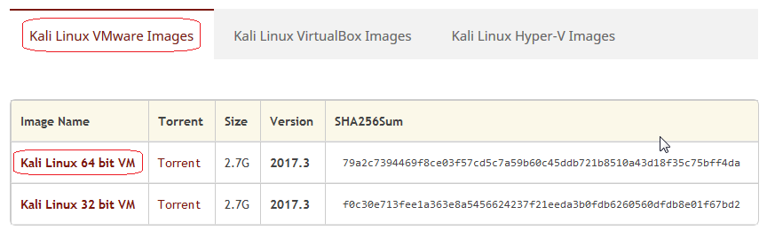

If your Free Download Manager is associated with your browser, it should automatically open and prompt you to start the download. If not, just right click on the download method and select, Copy link location.

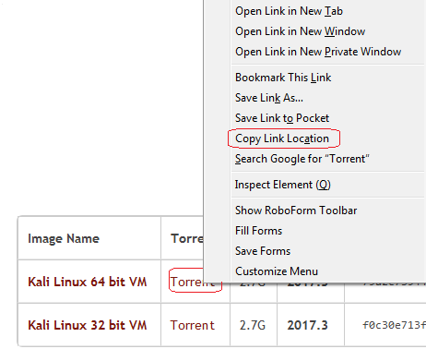

Open you Free Download Manager and click on the + sign in the upper left corner. The **Add Download** box appears. The link is already inserted. Click OK, and the download starts.

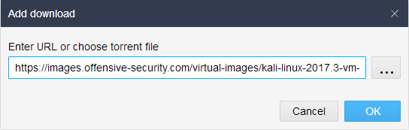

I choose to use a straight download as I have found there is not much difference in the time it takes to download this image one way or the other.

The same method used to get the normal download link applies to either the image or the full ISO image.

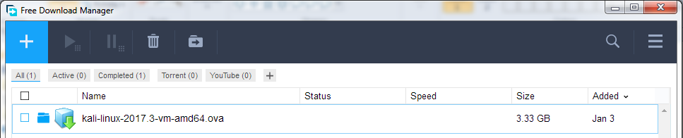

Browse to your download location for the VMWARE image. Right-click and select ‘open with.’

From the context menu select your version of VMWare player

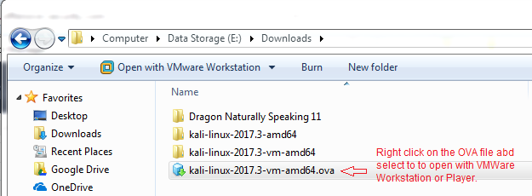

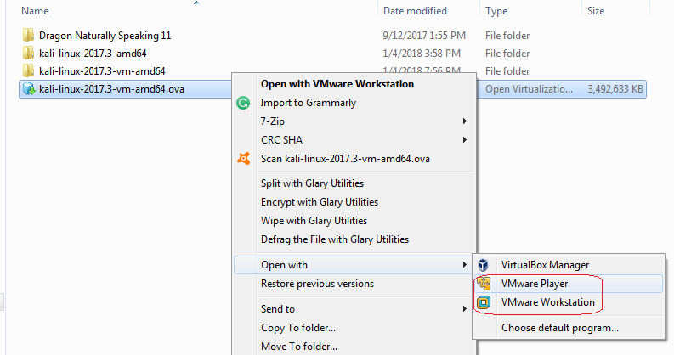

(Other than the management console interface, there is no difference in the VMWare wizard for creating or importing a virtual appliance. The major differences are the Workstation Pro costing $250.00, the VMWare Player is free, and the Pro version only comes with a 14-day free trial.)

The OVA image is imported into VMware player or Workstation using the Import Virtual Machine Wizard. Click on the button.

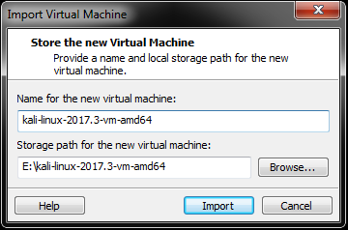

The importation process begins.



When the import is completed, your Kali install is ready. For the Username, type in root and for the password, type in toor, root spelled backward.

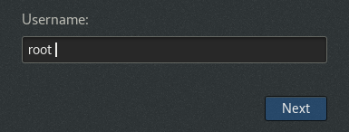

Hit the **sign in** button and congratulations; Kali is now installed

**Stop Kali from logging you out!**

After being idle for just 5 minutes, Kali will you log off. To get back to login box, hit the enter key. Type in your password of toor

To prevent this from happening, we can adjust the power setting to **never**. At the top right corner, click on the down arrow then the icon for the settings properties.

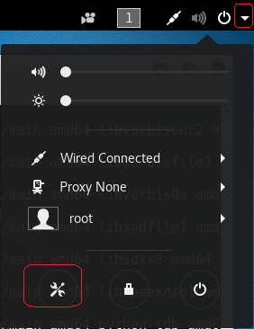

Click on the Power program.

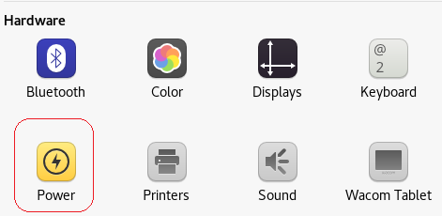

Under Power Savings, pull down the window to the right and select ‘never’ for the bottom of the window.

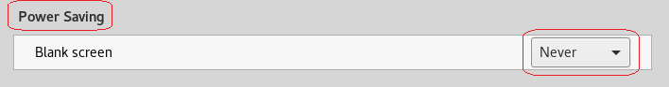

Close the Power window.

To shut down or restart Kali, do it just as if you were gracefully shutting down or restarting your host machine. Do not just power off VMWare as this will corrupt your Kali install!

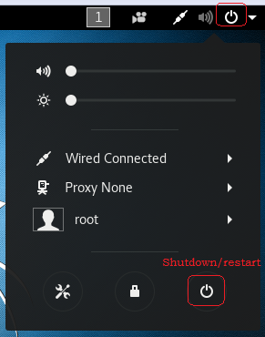

The following screen pops up, select your option.

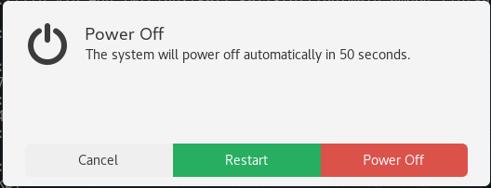

**Updating Your Kali Install**

**Caveat!**

**If this is your first time installing and updating a Linux machine, you are in for genuine real-world experience. Linux, regardless of what distro or version you use is all about updating and customizing your install with packages and files on a regular basis. This is a time-consuming process, and depending on the quality of your Internet, your hardware, disk space and the packages you wish to install, the updating can take some time to complete.**

**Rules to follow when updating Kali:**

* **You must be patient!**
* **You must not interrupt the update process!**
* **You need to update, or things will not work as described in the lab.**

To update Kali open a terminal session and type:

apt-get update && apt-get upgrade -y

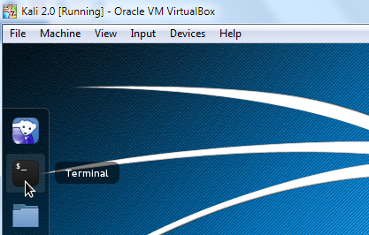

This will make sure Kali checks the most recent repository for any software updates. Once this process completes,

**Summary**

As you witnessed, there was no install or configuring of Kali. That’s the magic of using a ready built virtual image. We see a lot of readymade virtual images available from the different distros of Kali. Surprisingly, not from commercial versions of Linux, just the free and open source versions.

Each time you access Kali or any version of Linux, you should run the **apt-get update** command to ensure that you always have the latest packages.

Microsoft also supplies [readymade virtual images](https://developer.microsoft.com/en-us/microsoft-edge/tools/vms/) for their desktop clients. These expire after 90 days but a snapshot (VMWare Pro Version) can be taken any time before they expire, and the trial version begins anew. These are designed for developers

The take away from this lab should be:

1. Virtualization is a great tool for getting familiar with Linux or any operating system.
2. Readymade images can be used to reduce the learning curve and speed up the learning process.
3. Virtualization is a great way to test for software compatibility issues before you commit.
4. Free does mean inferior.

End of the lab!